# The Concept of the Cybertruck

## Section A

### Concept

Rapidly reducing carbon emissions across all sectors of the economy is key to the decline of climate change and its potential consequences. In the United States, light-duty vehicles (LDVS) now occupy around half of U.S. transportation emissions and a great part of sales ([The role of pickup truck electrification in the decarbonization of light-duty vehicles - IOPscience](https://iopscience.iop.org/article/10.1088/1748-9326/ac5142/meta)). In this context, innovative solutions like Tesla's Cybertruck and Semi Truck are gaining attention. These electric vehicles are designed to offer a sustainable energy alternative truck, which aims to replace around 6500 fuel-powered trucks that are sold in the United States every day (Musk, Elon November 5 2018 [Elon Musk: The Recode interview - Vox](https://www.vox.com/2018/11/2/18053424/elon-musk-tesla-spacex-boring-company-self-driving-cars-saudi-twitter-kara-swisher-decode-podcast)). By integrating such electric vehicles into the market, there is a potential to significantly decrease the carbon emissions of the transportation sector, aligning with broader environmental goals([The role of pickup truck electrification in the decarbonization of light-duty vehicles - IOPscience](https://iopscience.iop.org/article/10.1088/1748-9326/ac5142/meta)).

### The Background of Cybertruck

The initial concept of the Cybertruck can be traced back to Elon Musk's long-standing vision of creating an electric pickup truck that could match or exceed the capabilities of traditional gasoline-powered trucks. The idea began to take shape in public discourse around 2012 when Musk first mentioned his intention to develop a Tesla pickup truck ([Elon Musk on X: "@DJjodes Would love to make a Tesla supertruck with crazy torque, dynamic air suspension and corners like its on rails. That'd be sweet..." / X (twitter.com)](https://twitter.com/elonmusk/status/230487450882019328)). Over the years, this vision evolved through various stages of planning and development, culminating in the reveal of the prototype in 2019 ([The Tesla Cybertruck's Long And Complicated History Explained (slashgear.com)](https://www.slashgear.com/1211199/the-tesla-cybertrucks-long-and-complicated-history-explained/)2023, [Elon Musk unveils Tesla's electric Cybertruck (cnbc.com)](https://www.cnbc.com/amp/2019/11/21/tesla-cybertruck-unveiled.html)).

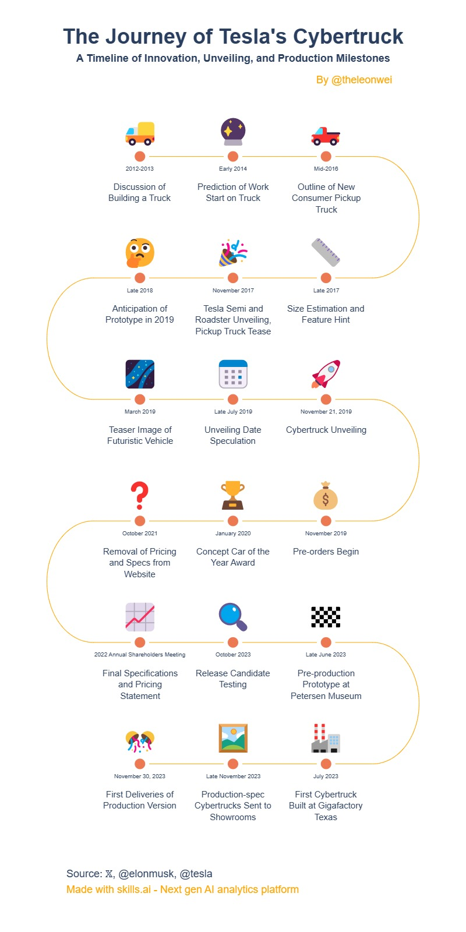

(Figure 1 [The Journey of Tesla's Cybertruck - A Timeline of Innovation (skills.ai)](https://skills.ai/infographics/the-journey-of-teslas-cybertruck-34e/))

(Achieve: The design of the Cybertruck is futuristic, with its sharply angled stainless-steel panels bolted directly onto a steel monocoque frame. This design requires bending stainless steel and overcoming the difficulty of creating unsightly creases. To overcome this challenge and achieve high levels of precision in stamping, Tesla innovatively employed Air Bending([Tesla’s Innovative Air Bending: Shaping the Future of Stainless Steel Manufacturing | by Aaron Smet | The Tesla Digest | Medium](https://medium.com/the-tesla-digest/teslas-innovative-air-bending-shaping-the-future-of-stainless-steel-manufacturing-8a3dc5d680af); [Tesla Cybertruck Review 2024 | Top Gear](https://www.topgear.com/car-reviews/tesla/cybertruck)). This technique was not only chosen to enhance the vehicle's futuristic aesthetic but also to ensure its strength and durability ([Tesla Cybertruck Review 2024 | Top Gear](https://www.topgear.com/car-reviews/tesla/cybertruck)).)

### Stakeholder Analysis

The stakeholders of the Cybertruck include groups and individuals both internal and external stakeholders of Tesla, who influence the success of the Cybertruck. This includes Tesla's manufacturing and marketing teams, the customers who would like to buy it, the government, Cybertruck supply partners and even Tesla's competitors ( [(99+) Tesla Motors Inc. Stakeholders' analysis | Egor Abakumov - Academia.edu](https://www.academia.edu/35202361/Tesla_Motors_Inc_Stakeholders_analysis); [The_Tesla_Phenomena-libre.pdf (d1wqtxts1xzle7.cloudfront.net)](https://d1wqtxts1xzle7.cloudfront.net/46138397/The_Tesla_Phenomena-libre.pdf?1464803200=&response-content-disposition=inline%3B+filename%3DThe_Tesla_Phenomena_A_Business_Strategy.pdf&Expires=1711786651&Signature=ZiDl9a9hnHRLCSeB1Eu6Dkg1OJ0rODTRJjJdPWvRvZDBuANrPKkmwfumEkqnWJJKTPGdREQ-iUyNAHY2C4X6RK-jqFbXDyV8-BdGZhhT7fNkXSPnDlHfZR-3fwPm7YbMB6wuigqGeaQP-2Q9CnL3mKDzQqJvS~YcOkPHNsL8o4uvUdasF7HGs7omEuqsqsjyqOKHPGV-0A3Rqto2HtfWDTFIBDX8i-WSwfOZBa2p~Gf0IFKGwjou3kZcOtoJaIeApFMVEafCP2JblRVP3gY9bs1qIT6hlwqOT6hjZglrPFgpaQgkEdEGL4lSyJTcLxpWCx-eT7RccAFc5t8iIzcG2w__&Key-Pair-Id=APKAJLOHF5GGSLRBV4ZA)). Below is a display of the stakeholders for the Cybertruck:

Internal:

* Tesla Board Members
  + Elon Musk: CEO, Vaibhav Taneja: CFO, Director of Tesla ([tsla-20231231-gen.pdf (tesla.com)](https://ir.tesla.com/_flysystem/s3/sec/000162828024002390/tsla-20231231-gen.pdf))
* Engineering and Design Team
* Marketing and Sales Team
* Production Team

External:

* Customers
* Governments
  + Department of Transport of all the countries
* Competitors
  + All electric truck brands
  + Rivian, Ford, GMC, Chevrolet([Top 10 Electric Pickup Trucks | Top Gear](https://www.topgear.com/car-news/electric/here-are-12-electric-pickups-you-need-know-about); [Top 10: Electric Pickup Trucks | EV Magazine](https://evmagazine.com/top10/top-10-electric-pickup-trucks); [Best Electric Trucks for 2024 and 2025, Tested (caranddriver.com)](https://www.caranddriver.com/rankings/best-pickup-trucks/electric))
* Investors and Shareholders
  + Elon Musk ([Who Owns Tesla: The Largest Shareholders Overview - KAMIL FRANEK Business Analytics](https://www.kamilfranek.com/who-owns-tesla-largest-shareholders/); [Who Owns Tesla stock? 10 Major Tesla Shareholders in 2024 (techopedia.com)](https://www.techopedia.com/largest-tesla-shareholders))
  + Institution Holding
    - Vanguard Group Inc., Blackrock Inc. etc ([Tesla, Inc. (TSLA) Institutional Holdings | Nasdaq](https://www.nasdaq.com/market-activity/stocks/tsla/institutional-holdings))
* Supply Chain Partners
  + Outokumpu ([Tesla Cybertruck stainless steel supplier revealed | Electrek](https://electrek.co/2023/10/11/tesla-cybertruck-stainless-steel-supplier-revealed/); [Tesla to use European steel supplier for Cybertruck panels: report (teslarati.com)](https://www.teslarati.com/tesla-cybertruck-to-use-european-steel-supplier-report/))
  + LG Innotek ([LG Innotek exclusive supplier of camera model for Tesla’s Cybertruck - THE ELEC, Korea Electronics Industry Media (thelec.net)](https://www.thelec.net/news/articleView.html?idxno=4700); [LG Innotek Mexico plant secures exclusive deal to supply camera modules for Tesla Cybertruck (digitimes.com)](https://www.digitimes.com/news/a20240104PD208/lg-innotek-mexico-camera-module-tesla-cybertruck.html)**;** [Tesla Cybertruck supplier competing for company’s Berlin Project  (teslarati.com)](https://www.teslarati.com/tesla-cybertruck-supplier-lg-innotek/))
  + Rongtai Share ([Tesla’s Cybertruck Success Boosts Chinese Suppliers in A-Share Markets | by Coulomb Counting | Medium](https://medium.com/@CoulombCounting/teslas-cybertruck-success-boosts-chinese-suppliers-in-a-share-markets-d3a266420732); [Tesla Cybertruck is a hit! A list of A-share listed companies with supporting value exceeding 2,000 yuan, with stock prices rising nearly 3 times over a year (futunn.com)](https://news.futunn.com/en/post/35239631?level=1&data_ticket=1711790411137741))

#### Stakeholder Matrix

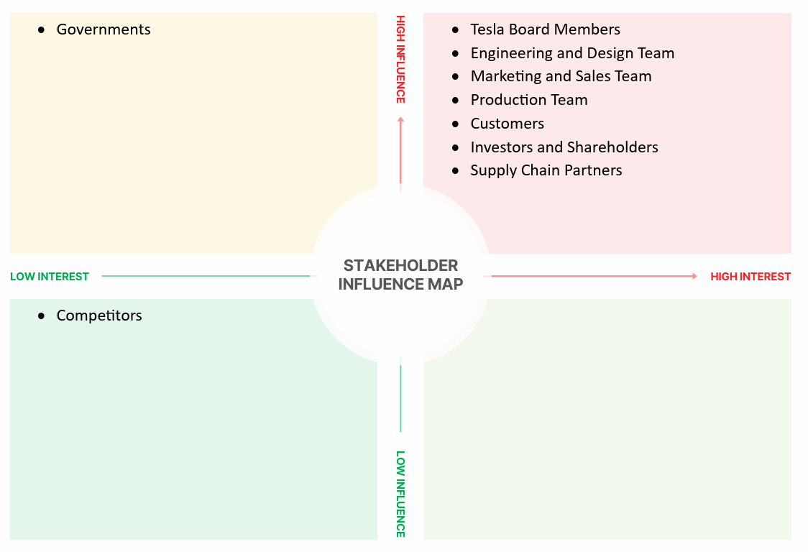

High Interest / High influence quadrant:

Tesla CEO, board members, engineering and design team, production team, customers, investors, and supply chain partners are in this quadrant. They played an important role in the success of the Cybertruck. This is because these stakeholders are not only very concerned about the project but also have a great impact on the result of the Cybertruck. For example, engineering and design teams determine the innovation and quality standards for Cybertruck, while customer recognition can define success in the market.

Low Interest / High influence quadrant:

The government does not have an interest in the project, but it is placed in this quadrant because of its regulatory powers that can have a significant impact on the project ([Tesla Cybertruck nears regulatory approval in Canada - Drive Tesla (driveteslacanada.ca)](https://driveteslacanada.ca/news/tesla-cybertruck-nears-regulatory-approval-in-canada/)). Their standards and regulations policy for pickup trucks and road approval could affect whether Cybertruck can be legally driven on the road([Tesla Cybertruck nears regulatory approval in Canada - Drive Tesla (driveteslacanada.ca)](https://driveteslacanada.ca/news/tesla-cybertruck-nears-regulatory-approval-in-canada/)). Tesla must ensure that Cybertruck is in compliance with the regulations of the Department of Transport in all countries and stay informed of policy changes to avoid any potential policy risks imposed by governments.

Low Interest / Low influence quadrant:

Competitors are in this quadrant because they are unimportant in the Cybertruck project. Even though they certainly observe the innovation of Tesla and the market environment, their actions cannot directly affect the project.

### Goals of the Project

Based on the background and understanding of stakeholders, the goals of the Cybertruck project are as follows:

#### Diversify Tesla's Product Range

The Cybertruck expands Tesla's product range by launching a new pickup truck category that complements the existing product line and attracts more customers([What Will Demand Be For The Cybertruck? (ark-invest.com)](https://ark-invest.com/articles/analyst-research/what-will-demand-be-for-the-cybertruck/)).

#### Increase Market Share

By entering the electric pickup market, Tesla can gradually occupy more share in this vehicle category market, and contribute to its goal of dominating the electric vehicle market.

#### Spark change in the pickup industry

By successfully launching and promoting the Cybertruck, Tesla can be an industry catalyst that encourages other automakers to accelerate the development of their electric vehicles and pickups.

#### Boost Reputation

The innovative and unique design of the Cybertruck has enhanced Tesla's brand profile and strengthened its reputation as the leader in the electric vehicles market ([Tesla's futuristic Cybertruck finally arrives—here's why the company's success is riding on it (techxplore.com)](https://techxplore.com/news/2023-11-tesla-futuristic-cybertruck-arriveshere-company.html); [5 Reasons Why the Cybertruck Is Tesla's Most Important Model to Date - autoevolution](https://www.autoevolution.com/news/5-reasons-why-the-cybertruck-is-tesla-s-most-important-model-to-date-226996.html)).

#### Strengthen industry leadership

Enhancing Tesla's leadership in the electric truck industry with the Cybertruck. By keeping the Cybertruck appealing and trending, Tesla distinguishes itself from rival electric truck manufacturers ([5 Reasons Why the Cybertruck Is Tesla's Most Important Model to Date - autoevolution](https://www.autoevolution.com/news/5-reasons-why-the-cybertruck-is-tesla-s-most-important-model-to-date-226996.html)). This strategy will ensure that Cybertruck not only captures and maintains customer interest, but also secures Tesla's edge in the electric vehicle market.

#### Investor Confidence

Realising the Cybertruck project could build investor confidence, demonstrate Tesla's continued commitment to innovation and market leadership, and support the company's valuation and stock.

## Section B

### Risk identifies

#### Risk register

|  |  |  |
| --- | --- | --- |
| Risk Description | Root Cause | Triggers |
| Supply chain disruptions could delay production | Critical materials depend on specific suppliers | Political instability, pandemics |
| Problems with regulatory approval | Strict regulatory standards and changing policies | New regulations, lack of compliance |
| Negative public perception impacts brand reputation | Public relations mishaps, product issues | Negative media coverage, social media backlash |
| Key personnel affect the project | Job dissatisfaction, competitive job market | Resignations, better offers from competitors |
| Manufacturing challenges | The design and the requirement for high precision in manufacturing | Production errors, scaling issues, technological limitations |

#### Reason

##### Supply chain disruptions could delay production

The Cybertruck’s supply chain relies on a specific, possibly single-source supplier of key components, making it vulnerable to disruptions or delays, such as its batteries ([Tesla Cybertruck deliveries hostage to battery production hell | Reuters](https://www.reuters.com/business/autos-transportation/austin-we-have-problem-tesla-descends-into-battery-hell-2023-12-21/)). While Tesla has some control over its supply chain, external factors like political instability or a global pandemic could still cause significant disruption ([Tesla halts Cybertruck orders | GoAuto](https://www.goauto.com.au/news/tesla/cybertruck/tesla-halts-cybertruck-orders/2022-05-18/87877.html), [Tesla's Cybertruck is finally hitting the streets. Here's what to know. : NPR](https://www.npr.org/2023/11/30/1216083781/tesla-cybertruck-release-musk)). This ultimately has a big impact, as any delay in getting the necessary materials for Cybertruck can directly affect the production schedules and finally impact Tesla's reputation and performance ([The Tesla Cybertruck Rolls Off the Line - ReadWrite](https://readwrite.com/the-tesla-cybertruck-rolls-off-the-line/)).

##### Problems with regulatory approval

The Cybertruck has faced challenges in regulatory approval in Europe ([Tesla Cybertruck's stiff structure, sharp design raise safety concerns -experts | Reuters](https://www.reuters.com/business/autos-transportation/tesla-cybertrucks-stiff-structure-sharp-design-raise-safety-concerns-experts-2023-12-08/)), China ([Musk Admits It’s ‘Very Difficult’ To Make Cybertruck Road Legal For China | Carscoops](https://www.carscoops.com/2024/01/musk-admits-its-very-difficult-to-make-cybertruck-road-legal-for-china/)) and Australia ([Tesla Cybertruck not coming to Australia – for now - Drive](https://www.drive.com.au/news/tesla-cybertruck-not-coming-to-australia-for-now/)), mainly because its unique design does not meet local standards. In the European Union, the heavy weight of Cybertruck requires a special driver's license to drive, and the charging interface is not adapted to the European CCS standard, which aggravates the difficulty of European market acceptance ([Why Elon Musk's Cybertruck Won't Be Coming to Europe Anytime Soon (businessinsider.com)](https://www.businessinsider.com/cybertruck-elon-musk-tesla-not-sold-europe-anytime-soon-2023-12); [We're about to find out how dangerous the Cybertruck really is. (slate.com)](https://slate.com/technology/2023/12/cybertruck-safety-elon-musk-tesla-danger.html); [Tesla Cybertruck's stiff structure, sharp design raise safety concerns -experts | Reuters](https://www.reuters.com/business/autos-transportation/tesla-cybertrucks-stiff-structure-sharp-design-raise-safety-concerns-experts-2023-12-08/)). At the same time, the size and sharp design of the Cybertruck have raised safety concerns, particularly with pedestrian safety codes ([We're about to find out how dangerous the Cybertruck really is. (slate.com)](https://slate.com/technology/2023/12/cybertruck-safety-elon-musk-tesla-danger.html); [Musk Admits It’s ‘Very Difficult’ To Make Cybertruck Road Legal For China | Carscoops](https://www.carscoops.com/2024/01/musk-admits-its-very-difficult-to-make-cybertruck-road-legal-for-china/); [Tesla Cybertruck's stiff structure, sharp design raise safety concerns -experts | Reuters](https://www.reuters.com/business/autos-transportation/tesla-cybertrucks-stiff-structure-sharp-design-raise-safety-concerns-experts-2023-12-08/)). While Tesla plans to adapt to the regulations, market acceptance remains unclear, posing significant market access and brand reputation risks.

##### Negative public perception impacts brand reputation

While direct criticism of the Cybertruck has been limited, Tesla's overall brand recognition has been affected by Elon Musk's actions and statements, particularly his controversial relationship with Twitter and his political views and statements ([Elon Musk’s Twitter Politics Add to Pressure on Tesla’s Brand Image - WSJ](https://www.wsj.com/articles/elon-musks-twitter-politics-add-to-pressure-on-teslas-brand-image-11669764014); [Here comes the Cybertruck, loaded with controversy - E&E News by POLITICO (eenews.net)](https://www.eenews.net/articles/here-comes-the-cybertruck-loaded-with-controversy/#:~:text=They%20include%20EV%20advocates%2C%20many,controversial%20thing%20about%20the%20Cybertruck.)). Musk has affected Tesla's image and caused some consumers to reconsider their previous brand loyalty ([Elon Musk’s Twitter Politics Add to Pressure on Tesla’s Brand Image - WSJ](https://www.wsj.com/articles/elon-musks-twitter-politics-add-to-pressure-on-teslas-brand-image-11669764014); [Tesla’s Brand Is Tanking, Survey Finds (forbes.com)](https://www.forbes.com/sites/alanohnsman/2023/01/12/teslas-brand-is-tanking-survey-finds/?sh=62a64f872b78)). This shift in public perception is more closely related to Musk than Cybertruck, but it will indirectly affect the acceptance and sale of Cybertruck, as the brand's reputation plays an important role in consumers' decisions ([Elon Musk’s Twitter Politics Add to Pressure on Tesla’s Brand Image - WSJ](https://www.wsj.com/articles/elon-musks-twitter-politics-add-to-pressure-on-teslas-brand-image-11669764014); [Tesla’s Brand Is Tanking, Survey Finds (forbes.com)](https://www.forbes.com/sites/alanohnsman/2023/01/12/teslas-brand-is-tanking-survey-finds/?sh=62a64f872b78)). As a result, there is a risk of negative public perception affecting the success of Cybertruck.

##### Key personnel affect the project

Mustapha El Akkari, head of the supply chain for Tesla's Cybertruck, recently moved to Rivian, a direct competitor of Tesla's Cybertruck which highlights the human resources risks facing the project ([Tesla's Cybertruck Supply Chain Lead Quits to Work at Rival Rivian (gizmodo.com.au)](https://gizmodo.com.au/2023/06/teslas-cybertruck-supply-chain-lead-quits-to-work-at-rival-rivian/); [Tesla's Cybertruck Stalled As Key Supply Chain Manager Jumps Ship to Rivian, Causing More Delays (yahoo.com)](https://finance.yahoo.com/news/teslas-cybertruck-stalled-key-supply-170013976.html?guccounter=1&guce_referrer=aHR0cHM6Ly93d3cuZ29vZ2xlLmNvbS8&guce_referrer_sig=AQAAAMmNODsP6YqhJzRo-XaUxGNjwxOHnEKHNHsK2o1vqNrFrq5FqMf6Nj-JRjCOXD-FB4Ul_ZwxYSarTYzLKj8gGb87YacoZmQ4MpmJbJYHQgw5JIsQPiCUSAYZ9HHqlF3QF1fJ6d28yEJaJBAmDz2M8Al3T4uDje_ofUOUMysJNXid)). El Akkari is not the only one to leave, all of whom have played key roles at Tesla or within the Cybertruck project, directly influencing Cybertruck's production schedule and cost strategy([Tesla's Cybertruck Supply Chain Lead Quits to Work at Rival Rivian (gizmodo.com.au)](https://gizmodo.com.au/2023/06/teslas-cybertruck-supply-chain-lead-quits-to-work-at-rival-rivian/); [Tesla's Cybertruck Stalled As Key Supply Chain Manager Jumps Ship to Rivian, Causing More Delays (yahoo.com)](https://finance.yahoo.com/news/teslas-cybertruck-stalled-key-supply-170013976.html?guccounter=1&guce_referrer=aHR0cHM6Ly93d3cuZ29vZ2xlLmNvbS8&guce_referrer_sig=AQAAAMmNODsP6YqhJzRo-XaUxGNjwxOHnEKHNHsK2o1vqNrFrq5FqMf6Nj-JRjCOXD-FB4Ul_ZwxYSarTYzLKj8gGb87YacoZmQ4MpmJbJYHQgw5JIsQPiCUSAYZ9HHqlF3QF1fJ6d28yEJaJBAmDz2M8Al3T4uDje_ofUOUMysJNXid)). Joining Rivian not only brings disruption to Tesla's supply chain but also accelerates the development of electric pickup trucks of Tesla's direct competitors ([Tesla v. Rivian: Electric Competition Over Trade Secrets - Harvard Journal of Law & Technology](https://jolt.law.harvard.edu/digest/tesla-v-rivian-electric-competition-over-trade-secrets)). This shift highlights the vulnerability of projects to key personnel changes, especially at critical stages such as the production phase. Losing such a central figure can disrupt established workflows and delay project timelines.

##### Manufacturing challenges

The manufacturing process of the Cybertruck is unprecedented ([Tesla's Musk raises Cybertruck production concerns, reveals delivery date | Reuters](https://www.reuters.com/business/autos-transportation/teslas-musk-raises-cybertruck-production-concerns-reveals-delivery-date-2023-10-19/)) may be because of its unique design and materials ([Tesla's Cybertruck Supply Chain Lead Quits to Work at Rival Rivian (gizmodo.com.au)](https://gizmodo.com.au/2023/06/teslas-cybertruck-supply-chain-lead-quits-to-work-at-rival-rivian/), [The Tesla Cybertruck Rolls Off the Line - ReadWrite](https://readwrite.com/the-tesla-cybertruck-rolls-off-the-line/)). Any small defects on the flat, angular surfaces of Cybertruck are very noticeable and therefore it requires perfect production accuracy. The precision required for its bright metal body and straight edges will make it difficult to scale up Cybertruck production ([Why the Cybertruck is so hard to manufacture (cnbc.com)](https://www.cnbc.com/2023/12/13/why-the-cybertruck-is-so-hard-to-manufacture.html)). As a result, these obstacles will limit the mass production of Cybertruck by creating production bottlenecks ([Tesla stops taking orders for Cybertruck outside North America (cnbc.com)](https://www.cnbc.com/2022/05/17/tesla-stops-taking-orders-for-cybertruck-outside-north-america.html#:~:text=U.S.%20electric%20vehicle%20manufacturer%20Tesla,and%20Mexico%2C%20the%20website%20showed.); [Why Elon Musk's Cybertruck Won't Be Coming to Europe Anytime Soon (businessinsider.com)](https://www.businessinsider.com/cybertruck-elon-musk-tesla-not-sold-europe-anytime-soon-2023-12)).

## Section C

Section 3: Risk Mitigation Recommendations

Risk: Supply Chain Disruptions

Recommendation:

To mitigate the risk of supply chain disruptions, Tesla should diversify its supplier base to avoid relying on a single source of suppliers. A multi-vendor strategy can reduce the impact of outages by ensuring that there are alternative sources when one vendor is facing difficulties. In addition, Tesla could strengthen its inventory management strategy, such as maintaining safety stocks of key components. Strengthening relationships with suppliers and regularly reviewing supply chain resilience plans could also help Tesla respond quickly to unforeseen disruptions.

Risk: Problems with Regulatory Approval

Recommendation:

In the early stages of vehicle design and development, Tesla should actively engage with regulators in key markets, rather than solely based on Musk's independent judgment. This allows Cybertruck to meet all local safety and environmental standards. Establishing a dedicated regulatory affairs team could help Tesla keep abreast of regulatory changes and facilitate vehicles to adapt more quickly to different market needs.

Risk: Negative Public Perception Impacts Brand Reputation

Recommendation:

To address the risk of negative public perception, Tesla should invest in a transparent and consistent communication strategy that emphasizes the benefits and safety features of the Cybertruck. In addition, actively managing Elon Musk's public statements and their impact on brand perception may be critical. Implementing reputation management practices such as monitoring social media sentiment can help mitigate potential risk backlash.

Risk: Key Personnel Affect the Project

Recommendation:

To minimize the impact of key departures, Tesla should strengthen its talent retention strategy. This may include a competitive compensation package, as well as a strong organizational culture that promotes loyalty and reduces attrition. In addition, Tesla should have a robust succession planning process in place to identify and develop potential leaders for key roles. Regular talent evaluation and leadership training can enhance a company's internal capabilities.

Risk: Manufacturing Challenges

Recommendation:

Considering the unique manufacturing requirements of Cybertruck, it may involve investing in advanced manufacturing technologies such as automation and precision engineering to ensure high-quality production without defects. Working with technology suppliers to develop custom manufacturing solutions can also help overcome specific production barriers. In addition, launching pilot production runs can help identify potential problems early and adjust processes accordingly before scaling up production or even before the product concept is released.

Execution

The execution phase of the Tesla Cybertruck project translates strategic planning and rigorous test results into a streamlined production process. This phase is critical as it focuses on effectively implementing design and production strategies to ensure timely delivery of Cybertruck while maintaining high quality and cost constraints.

Production increase

Tesla's original goal was to reach an annual production capacity of 250,000 vehicles by 2025, but the current production capacity is 125,000. However, there are significant challenges to achieving this goal, as Cybertrucks have accumulated more than 1 million pre-orders. The stainless steel design of the Cybertruck is different from the traditional automotive manufacturing process, which leads to more scale production issues and leads to production bottlenecks. These bottlenecks could cause Tesla's reputation to decline or customers to cancel orders, ultimately affecting the company's revenue. ([Tesla's Musk raises Cybertruck production concerns, reveals delivery date | Reuters](https://www.reuters.com/business/autos-transportation/teslas-musk-raises-cybertruck-production-concerns-reveals-delivery-date-2023-10-19/); [Tesla announces Cybertruck deliveries in November, claims 125,000 production capacity | Electrek](https://electrek.co/2023/10/18/tesla-cybertruck-deliveries-november-production-capacity/)).

Quality Control

Elon Musk himself emphasized the importance of quality for the Cybertruck, noting that the vehicle's unique design makes even small flaws obvious. This has led to an increased focus on achieving what Musk describes as "Lego-like precision" in manufacturing. However, after mass production began, numerous quality issues emerged, particularly large gaps between stainless steel panels and some reports of misalignment between the front and rear passenger doors. Thermal expansion and contraction during vehicle operation can exacerbate these issues, making them more prominent. ([Musk unhappy with Cybertruck’s poor quality, calls for Lego-like precision | Ars Technica](https://arstechnica.com/cars/2023/08/tesla-cybertrucks-bad-build-quality-shows-up-like-a-sore-thumb-musk-says/); [The first Tesla Cybertruck to roll off the line confirms Tesla's design problems (fastcompany.com)](https://www.fastcompany.com/90925930/first-cybertruck-tesla-design-problems))

Ex recom

In order to meet the challenges facing the execution phase of the Tesla Cybertruck project, especially in terms of production ramp-up and quality control, Tesla had to take several strategic steps. First, to effectively manage demand and bookings, Tesla should consider expanding its manufacturing capacity by expanding existing factories or building new ones, especially focusing on areas closer to key markets to reduce logistical challenges and response times. While expanding production capacity, the supply chain should also be strengthened, inventory should be optimized, and the steady flow of key materials should be ensured to avoid production delays.

In terms of quality control, Tesla needs to increase its focus on manufacturing precision, possibly by investing in advanced automation technology to help achieve the desired "Lego-like precision." More stringent quality assurance checks are implemented at every stage of the manufacturing process, which will help to detect and correct defects early, thereby maintaining the high standards required of Cybertrucks. In addition, training programs for production personnel should be strengthened to increase awareness of handling the unique materials and design specifications of cybertrucks.

Finally, Tesla should consider a strategy of proactively communicating with customers to let them know about the status of their orders and any potential delays. Even in the face of production challenges, transparency can help manage customer expectations and maintain trust. Taken together, these measures will not only help Tesla meet its production goals, but also ensure quality and customer satisfaction.